DWV Assignment 4
Bryn Swiston
library(readr)
Warning: package 'readr' was built under R version 4.5.2
your_data <- read_csv("protected_lands.csv")
New names:
Rows: 13 Columns: 7
── Column specification
──────────────────────────────────────────────────────── Delimiter: "," chr
(2): country, country_code dbl (3): protected_lands, gdp_percap,
tot_gdp_bilions lgl (2): ...6, ...7
ℹ Use `spec()` to retrieve the full column specification for this data. ℹ
Specify the column types or set `show_col_types = FALSE` to quiet this message.
• `` -> `...6`
• `` -> `...7`
plot(NA, xlim = c(-20, 20), ylim = c(-20, 20),
xlab = "x", ylab = "y", main = "y = 4x + 3",
asp = 1)
abline(h = 0, v = 0, col = "black")
grid()
abline(a = 3, b = 4, col = "Steelblue", lwd = 2.5, lty = "dashed")
text(3, 17, "y = 4x + 3", col = "HotPink", font = 2)
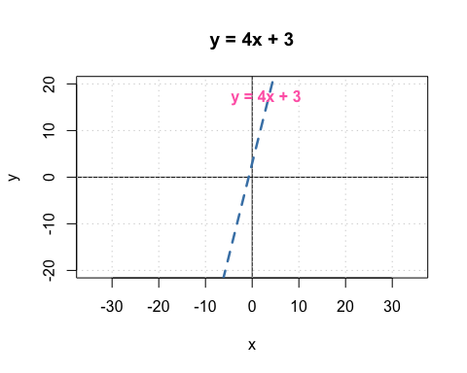
protected_lands <- read_csv("protected_lands.csv")
New names:
Rows: 13 Columns: 7
── Column specification
──────────────────────────────────────────────────────── Delimiter: "," chr
(2): country, country_code dbl (3): protected_lands, gdp_percap,
tot_gdp_bilions lgl (2): ...6, ...7
ℹ Use `spec()` to retrieve the full column specification for this data. ℹ
Specify the column types or set `show_col_types = FALSE` to quiet this message.
• `` -> `...6`
• `` -> `...7`
mean(protected_lands$protected_lands)
[1] 18.38462
sd(protected_lands$protected_lands)
[1] 10.89754
range(protected_lands$protected_lands)
[1] 4 42
mean(protected_lands$gdp_percap)
[1] 25210.38
sd(protected_lands$gdp_percap)
[1] 19337.7
range(protected_lands$gdp_percap)
[1] 3156 58553
mean(protected_lands$tot_gdp_bilions)
[1] 1125.923
sd(protected_lands$tot_gdp_bilions)
[1] 3056.297
range(protected_lands$tot_gdp_bilions)
[1] 20 11199
plot(protected_lands$gdp_percap, protected_lands$protected_lands,
main = "Protected Lands vs. GDP per Capita",
xlab = "GDP per Capita",
ylab = "Protected Lands (% of Total Land Area)",
pch = 19)
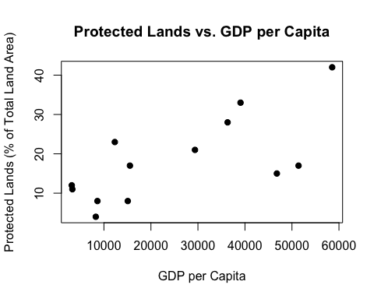
plot(protected_lands$tot_gdp_bilions, protected_lands$protected_lands,
main = "Protected Lands vs. Total GDP",
xlab = "Total GDP (Bilions)",
ylab = "Protected Lands (% of Total Land Area)",
pch = 19)
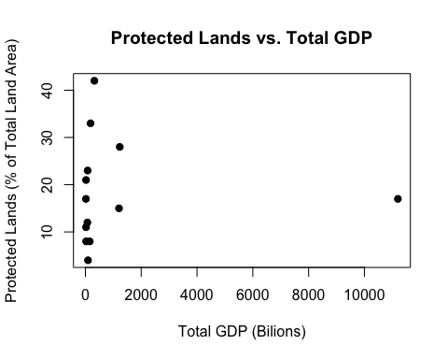
model <- lm(protected_lands ~ gdp_percap, data = protected_lands)
summary(model)
Call:
lm(formula = protected_lands ~ gdp_percap, data = protected_lands)
Residuals:
Min 1Q Median 3Q Max
-11.925 -6.373 1.292 5.223 10.420
Coefficients:
Estimate Std. Error t value Pr(>|t|)
(Intercept) 8.4075115 3.7882055 2.219 0.04842 *
gdp_percap 0.0003958 0.0001210 3.272 0.00744 **
---
Signif. codes: 0 '***' 0.001 '**' 0.01 '*' 0.05 '.' 0.1 ' ' 1
Residual standard error: 8.103 on 11 degrees of freedom
Multiple R-squared: 0.4932, Adjusted R-squared: 0.4471
F-statistic: 10.7 on 1 and 11 DF, p-value: 0.007443
plot(protected_lands$gdp_percap, protected_lands$protected_lands,
main = "Protected Lands vs. GDP per Capita",
xlab = "GDP per Capita",
ylab = "Protected Lands (% of Total Land Area)",
pch = 19)
model <- lm(protected_lands ~ gdp_percap, data = protected_lands)
abline(model, col = "red", lwd = 2)
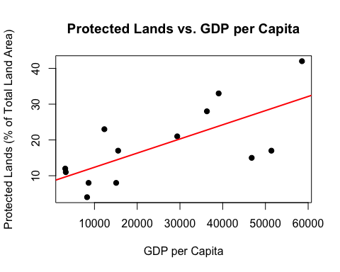
model2 <- lm(protected_lands ~ tot_gdp_bilions, data = protected_lands)
summary(model2)
Call:
lm(formula = protected_lands ~ tot_gdp_bilions, data = protected_lands)
Residuals:
Min 1Q Median 3Q Max
-14.393 -7.394 -1.394 4.607 23.609
Coefficients:
Estimate Std. Error t value Pr(>|t|)
(Intercept) 1.839e+01 3.381e+00 5.440 0.000204 ***
tot_gdp_bilions -8.177e-06 1.075e-03 -0.008 0.994067
---
Signif. codes: 0 '***' 0.001 '**' 0.01 '*' 0.05 '.' 0.1 ' ' 1
Residual standard error: 11.38 on 11 degrees of freedom
Multiple R-squared: 5.26e-06, Adjusted R-squared: -0.0909
F-statistic: 5.786e-05 on 1 and 11 DF, p-value: 0.9941
plot(protected_lands$tot_gdp_bilions, protected_lands$protected_lands,
main = "Protected Lands vs. Total GDP",
xlab = "Total GDP (Billions)",
ylab = "Protected Lands (% of Total Land Area)",
pch = 19)
abline(model2, col = "red", lwd = 2)
